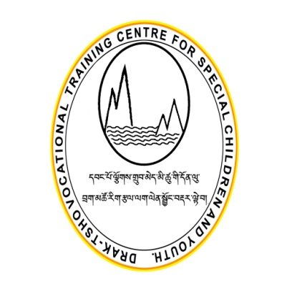

**DRAKTSHO VOCATIONAL TRAINING CENTRE FOR SPECIAL CHILDREN AND YOUTH**

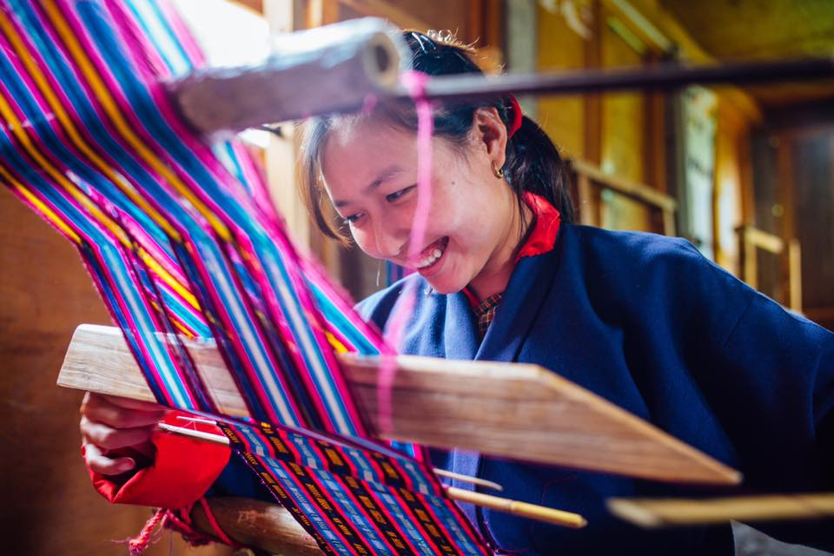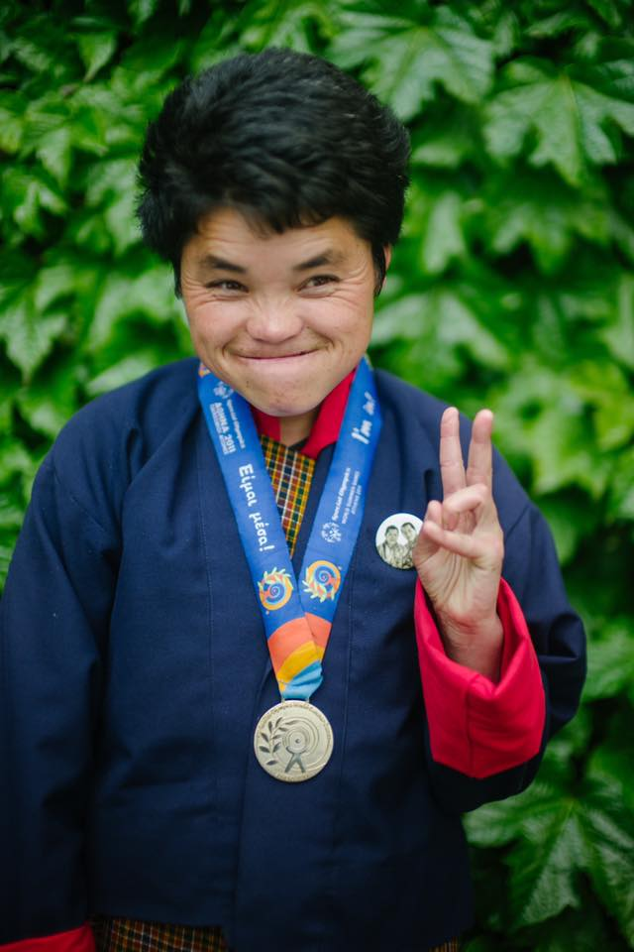

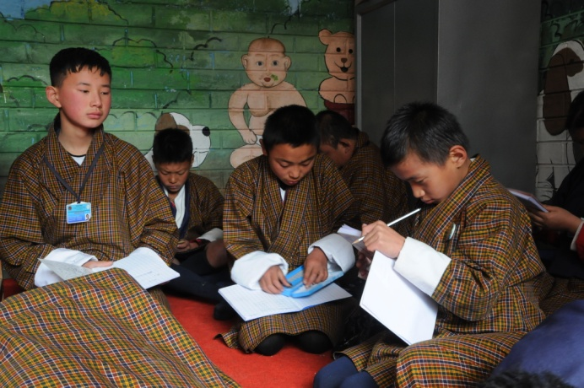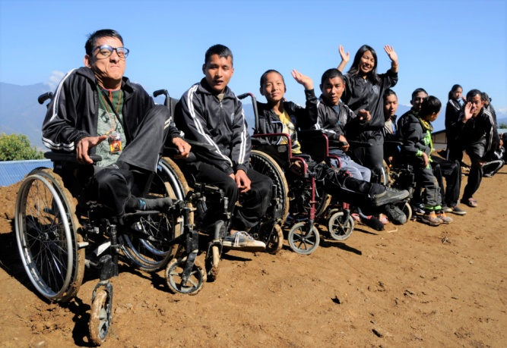

**Draktsho Annual Report 2018**

**Table of Contents**

1. **Foreword...........................................................................................................**
2. **Programs and Activities...................................................................................**
3. **World Down Syndrome Day ......................................................................**
4. **World Autism Day............................................................................................**
5. **Teachers Day ...................................................................................................**
6. **Jimba ................................................................................................................**
7. **Funfitness Day ..............................................................................................**
8. **Foundation Day**
9. **Community Participation ...........................................................................**
10. **Celebration of International Day of Persons with Disabilities ..................**
11. **Programmes and Activities ........................................................................**
12. **Success Stories .................................................................................................**
13. **Challenges .................................................................................................**
14. **Our Pledged Donors ......................................................................................**

**Foreword**

The aim of vocational education is to provide age-appropriate training support to change the substantial limitations in present functioning by identifying suitable training for youth with various types of disabilities and providing intensive training for the highly capable youth and rehabilitation type of training for the moderate and severely handicapped youth so that they may receive reasonable remuneration and a promising better quality of life.

Our focus has been on providing vocational training to students with various types of disabilities; however, this is not an easy task as there is not enough money to provide a wide range of services. There are many children who need special equipments for training which are very expensive. We need to include more training for intellectually challenged youth which require adequate space, equipments and more staff. There are children who are unprotected and disowned by families; these children need protection, education, a safe and caring place to live. Draktsho has been picking up many such children who have undergone unimaginable traumas and disadvantages of life.

Life they say is a blessing but for some it seems so unfair and cruel. Whatever it maybe I feel it is every body’s responsibility to see that every child is protected, is receiving education, training and equal opportunities. Draktsho is trying very hard to reach our services to all those who need them. In doing so, we have few generous members contributing to fulfill our cause and goals.

Draktsho is extremely grateful to all our pledged donors, sponsors and partners for the great contribution. Your contribution has lifted much stress and helped us concentrate on the development of all our students. You all have selflessly committed to join us in making a better life for our children and youth.

Draktsho is so lucky to have you supporting us and being part of our family.

Good luck and thank you

Rigzin Padma Tsogyal

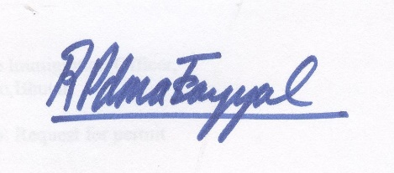

Founder/Director

Draktsho

**DRAKTSHO**

Drak-Tsho is currently the only parent initiated vocational training program in Bhutan that specifically targets children and young people who have a disability. Drak-Tsho is the first of its kind in the country; it’s a service- oriented and non-profit making centre which aspires to enhance the living standard of children and youth with disability through empowerment by training, education and eventual integration with the mainstream population. Its main focus is to equip the trainees with vocational training skills to enhance their opportunities for gainful employment. It also aims to build their self-esteem and self-reliance, thereby making them more independent, confident and contributing members of the society. The Centres (Thimphu & Kanlung, Tashigang) encompasses opportunities that allow them to grow in their aptitude, determination, goals and dreams. One of the greatest challenges for the centre is to erase the deeply embedded stigma.

The management staff of the Drak-Tsho promotes the recommendations recorded in the 2007 ‘Master Plan’. There have been a lot of activities at the Centre like the development of written curricula for life skills which would provide not only identifiable guidelines for the staff and students, but also a means of providing the basis for evaluation of the program and the progress of students. Lot of awareness raising programs have also been organized.

The first branch of Drak-Tsho, based in Kanglung, Tashigang caters the same kind of services that are taught at Thimphu Centre. Plans for including more traditional based training and conventional based training are being developed to engage every student.

## Our main objectives are:

1. To provide training in life skills including basic literacy and numeracy to persons with special needs for enabling them to cope with their daily life needs in present and future.
2. To equip trainees with special needs with vocational and work skills as preparation for sheltered, open or self-employment.
3. To facilitate the trainees with special needs secure work with dignity.
4. To initiate dialogue, build collaborations and networks with different stakeholders (government, industry, institutions etc) for actively promoting equal opportunities for people with special needs.
5. To organize parent support and community outreach program for raising awareness and generating support for inclusion of persons with special needs.
6. To conduct training, research and documentation for building human resources, supporting innovative actions and generating resource material and data for supporting quality services and advocacy.

While providing services and special education to children and youth with disabilities, Draktsho assures that all the International Days for people with Disabilities are celebrated. The first Day of celebration starts with the World Down Syndrome Day.

**World Down Syndrome Day**

Down Syndrome is a genetic occurrence caused by extra material in chromosome 21 that results in intellectual disability. It is not yet known why this occurs. The estimated incidence of Down Syndrome is between 1 in 1,000 to 1 in 1,100 live births worldwide. Each year approximately 3,000 to 5,000 children are born with this chromosome disorder and it is believed there are about 250,000 families in the United States of America who are affected by Down Syndrome.

In December 2011, the General Assembly declared 21st March as World Down Syndrome Day ([A/RES/66/149](http://www.un.org/en/ga/search/view_doc.asp?symbol=A/RES/66/149)). The General Assembly decided, with effect from 2012, to observe World Down Syndrome Day on 21st March each year, and invites all Member States, relevant organizations of the United Nations system and other international organizations, as well as civil society, including non-governmental organizations and the private sector, to observe World Down Syndrome Day in an appropriate manner, in order to raise public awareness of Down syndrome.

Every year Draktsho marks the World Down Syndrome Day through fun and awareness raising activities. In 2018 students of Draktsho participated in art and dance competition at Kuensel Phodrang (BuddhaPoint) showcasing their talents. Teachers, volunteers and parents also gathered to rejoice this special day with their children.

**World Autism Awareness Day**

**World Autism Awareness Day** is an [internationally recognized day](https://en.wikipedia.org/wiki/International_observance) on 2nd April every year, encouraging [Member States](https://en.wikipedia.org/wiki/Member_states_of_the_United_Nations) of the [United Nations](https://en.wikipedia.org/wiki/United_Nations) to take measures to raise awareness about people with [autism](https://en.wikipedia.org/wiki/Autism) throughout the world. It was designated by the [United Nations General Assembly](https://en.wikipedia.org/wiki/United_Nations_General_Assembly) resolution "62/139. World Autism Awareness Day", passed in council on 1 November 2007, and adopted on 18 December 2007. It was proposed by the United Nations representative from [Qatar](https://en.wikipedia.org/wiki/Qatar), Her Highness [Sheikha](https://en.wikipedia.org/wiki/Sheikha) [Mozah Bint Nasser Al-Missned](https://en.wikipedia.org/wiki/Moza_bint_Nasser), [Consort](https://en.wikipedia.org/wiki/Queen_consort) of His Highness [Sheikh](https://en.wikipedia.org/wiki/Sheikh) [Hamad Bin Khalifa Al-Thani](https://en.wikipedia.org/wiki/Hamad_bin_Khalifa_Al_Thani), the [Emir](https://en.wikipedia.org/wiki/Emir) of the State of Qatar, and supported by all member states.

This resolution was passed and adopted without a vote in the UN General Assembly, mainly as a supplement to previous UN initiatives to improve [human rights](https://en.wikipedia.org/wiki/Human_rights). World Autism Day is one of only four official health-specific UN Days. The day itself brings individual autism organizations together all around the world to aid in things like research, diagnoses, treatment, and overall acceptance for those affected by this [developmental disorder](https://en.wikipedia.org/wiki/Developmental_disorder).

On 2nd April Draktsho joined the world by Celebrating the Autism Day through a potluck picnic. Teachers, students and parents gathered at Sangay Gang(BBS Tower) for a picnic. Such special events helps bring everyone together to experience joy, happiness and share their knowledge about Autism, how to support people with Autism to live independent lives, speak out against discrimination and strengthen the family forums. This brings everyone together towards "social inclusion".

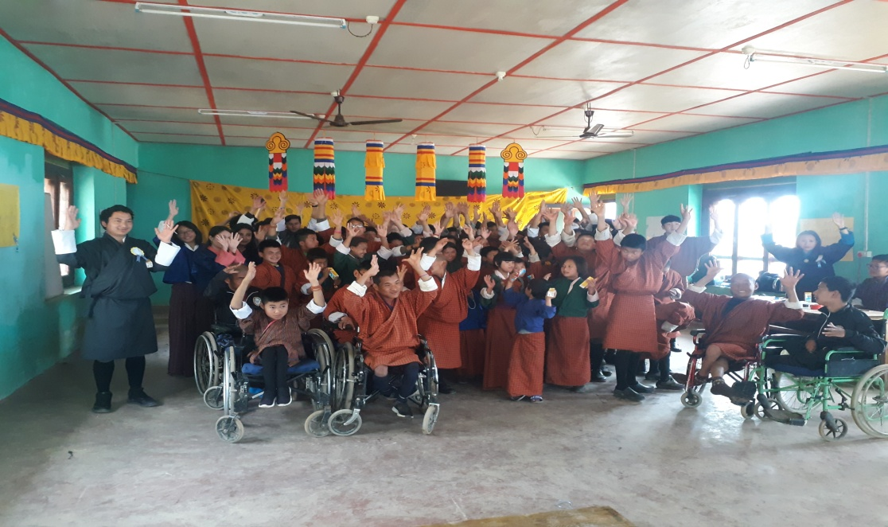

**Draktsho Dharma Day**

Saga Dawa is the fourth month of Lunar Calendar and it is the holiest month for all Tibetan Buddhists or Himalayan Buddhists. Saga Dawa is one such duezang or powerful auspicious time because the external and internal conditions are right, the historical Buddha, according to the Bhutanese calendar, is said to have experienced the five major events in his life on the full moon day of Saga Dawa. The Buddha is believed to have been conceived, born, to have defeated evil forces, attained enlightenment and passed away into Mahaparinirvana on this day.

To capitalize on the power of the month, it is important to avoid non-virtuous and harmful activities and engage virtuous and positive actions during the month. Remembering the Buddha and his enlightened activities, it is important to benefit others and wish all sentient beings to be free from suffering and to be enlightened.

Draktsho initiated a mass feeding program in 2016 to mark this auspicious month every year. Student, teachers, parents and volunteers gathered bringing their own food items such as mixed dough prepared in milk, sugar, bread, biscuits, cooked rice and other food items that can be consumed directly. This group divided into smaller groups and started their mass feeding program starting from the dogs within the compound. The groups dispersed in different directions feeding the dogs, ants, fishes, cats and cows. This not only excites all but it helps gain merit, purify one's mind, bring peace, joy and satisfaction to all involved through this good deed.

“*One moment can change a day, one day can change a life and one life can change the world.”****– Buddha***

**Teachers Day**

While the whole world celebrates teachers’ day generally on 5th October, there are countries that have adopted different dates to mark the same according to their national significance. For instance India our immediate neighbor country celebrates its national teachers’ day on 5th September, which is the birth date of the second president of India Dr. Saevepalil Radhakrishnan who was born in 1888.

Likewise Nepal our next immediate neighbor celebrates its national teachers’ day on a full moon day of Ashad which is also called Ashad suika purnima- the date which usually falls in mid –July. The day is called ‘Guri Purnima’ where ‘Guru’ means ‘teacher’ and ‘purnima’ means full moon.

In the similar way Bhutan celebrates its National Teachers’ Day on 2nd May, which marks the Birth Anniversary of His Majesty The Third King of Bhutan –His Majesty King Jigme Dorji Wangchuck. In the history of Bhutan The Third King is known as the Father of Modern Bhutan, and especially for the Education fraternity he is known as The Father of Modern Education in Bhutan.

Draktsho also commemorated the "Teachers Day" on 2nd June and as usual the students organized the entire program for the teachers.

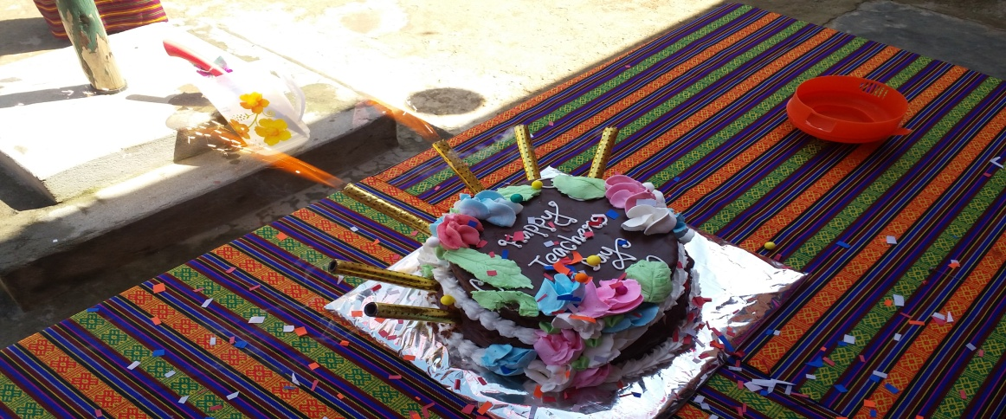 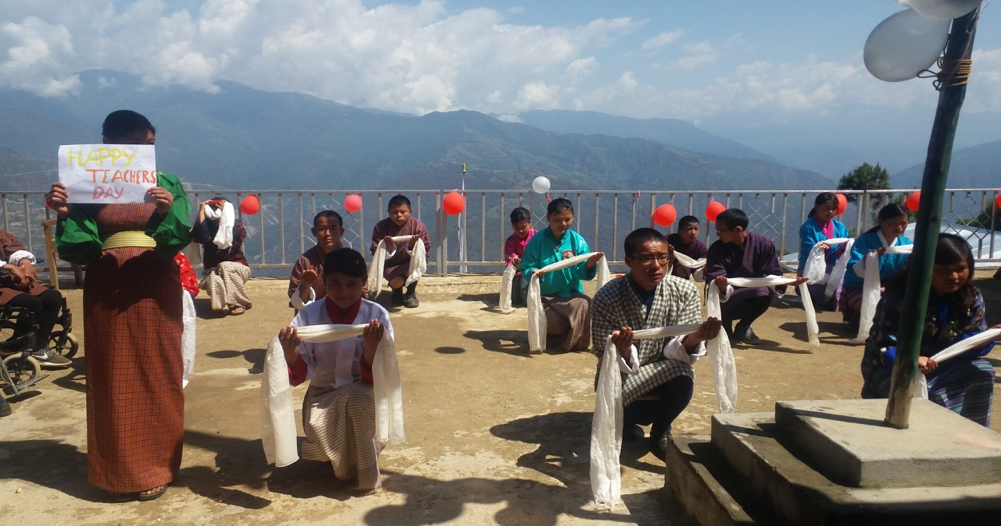

**FunFitness Day**

Funfitness is a physical therapy screening program that is designed to assess and improve physical strength, flexibility, and balance. The screenings also educate athletes and parents on the importance of staying physically fit and flexible and provide a hands-on opportunity for participating Special Olympics athletes to learn more about physical therapy. The Funfitness program was organized by Special Olympics Bhutan in collaboration with Draktsho and it was one of the first such programs conducted in the country. 100 athletes were screened Flexibility test, Strength test, Balancing ,Endurance test where the athlete steps in place for two minutes or walks for three minutes and Education: Athletes are provided with a written Home Exercise Program based on the test results.

This event was held on 20th May,2018 at Changangkha Conference Hall.

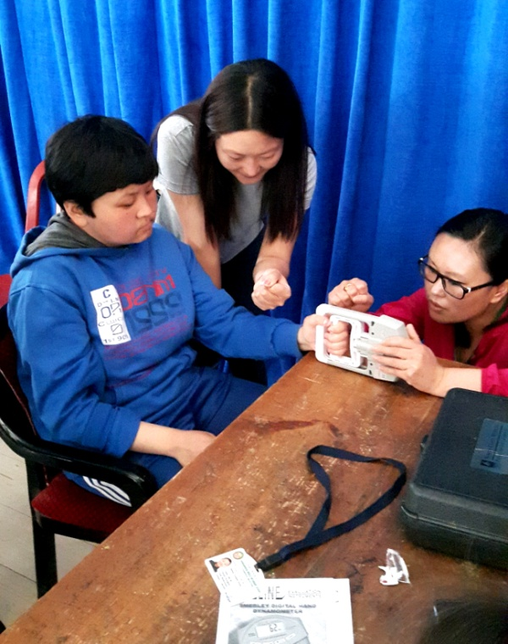 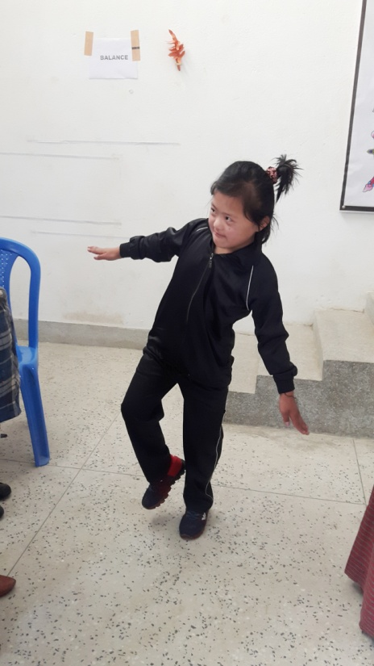

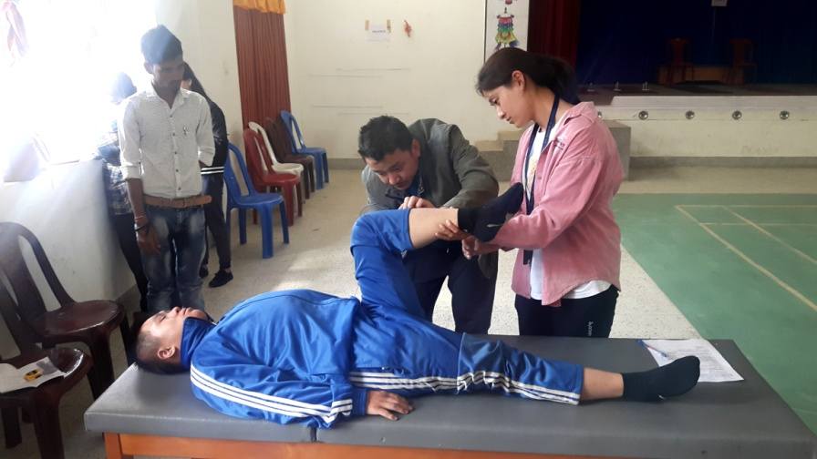

**Foundation Day** Draktsho marked its 17th years of establishment on 2nd October 2017. All the teachers, parents, students, volunteers and relatives celebrated the day at Tango Cheri base feasting on food, music and other outdoor fun events.

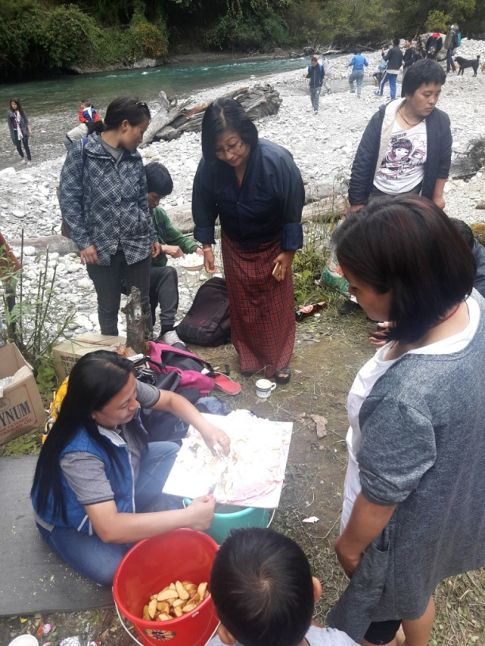 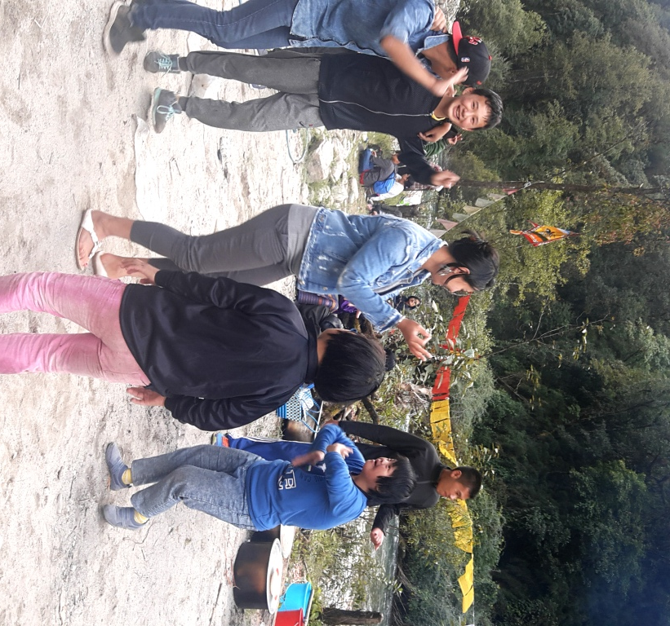

**Community Participation**

The Yongphula Tshechu is one of the most popular annual festivals in eastern Bhutan. People all over eastern Bhutan attend the three-day festival. The festival portrays Bhutanese culture in its full glory with sacred mask dances and traditional folk songs and dances entertaining crowds. The YonphulaTshechu falls every year from 9th-11th of the 10 month of lunar calendar. Students of Draktsho East Centre perform cultural programs at this 3 days Tshechu to create awareness about the abilities/capabilities of persons with disabilities. Many perceive that persons with disabilities do not have the capacity to live independently and contribute to the society. To create awareness amongst the community people of eastern Bhutan the students started participating along with other non disabled people during this festival. This event took place at

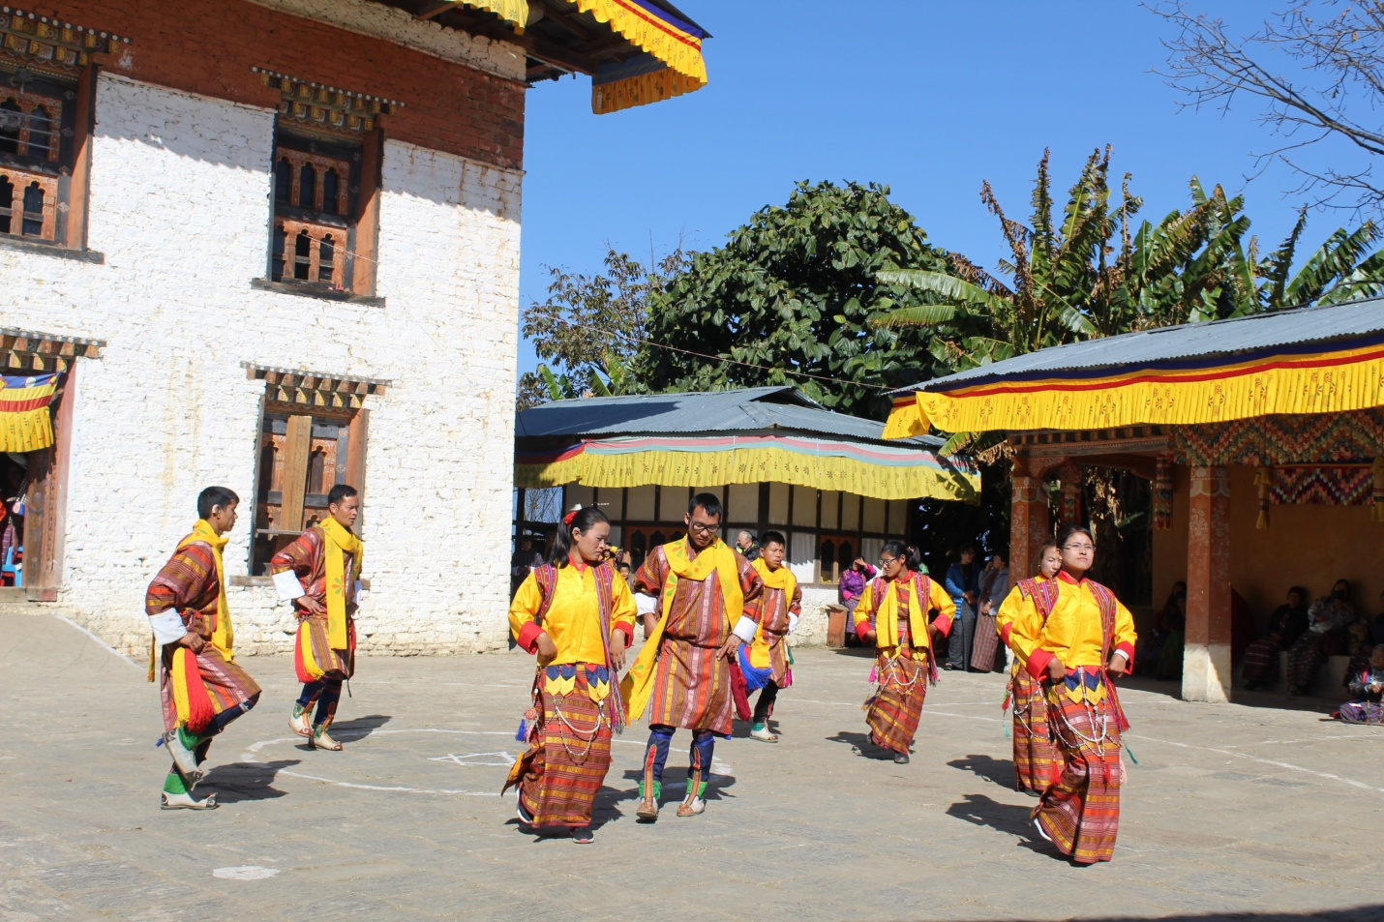

**Celebration of International Day of Persons with Disabilities**

Each year the [UN announces a theme](https://www.un.org/development/desa/disabilities/international-day-of-persons-with-disabilities-3-december/idpd2017.html) to observe for International Day of People with Disability. The annual theme provides an overarching focus on how society can strive for inclusivity through the removal of physical, technological and attitudinal barriers for people with disability. This has been occurring since 1992 when the General Assembly proclaimed 3rd December as the International Day of Persons with Disabilities. The theme for 2018 International Day of People with Disability "***Empowering persons with disabilities and ensuring inclusiveness and equality".*** The overarching principle of this theme is to ‘leave no one behind’ and empowers people with disability to be active contributors of society

Draktsho celebrated the day on 3rd December involving students to equally participate in a sports competition to showcase their abilities and talents through the medium of sports. As sport is one of the core activities of Draktsho's curriculum the students undergo training in sports once every week. They practice Special Olympic type of sports which keeps them fit, healthy, share joy and happiness while moving towards an inclusive society. About 100 students participated in the sports competition that was organized on 3rd December at the Athletic Ground.

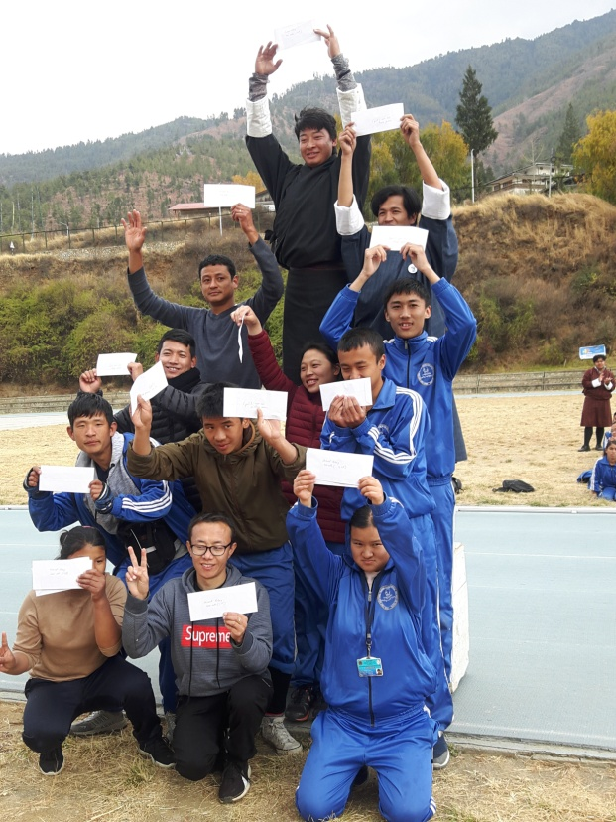 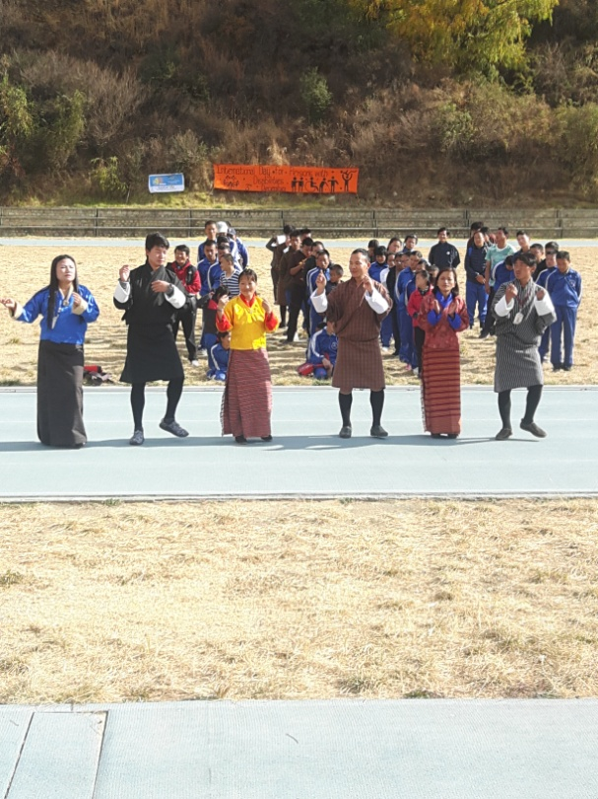

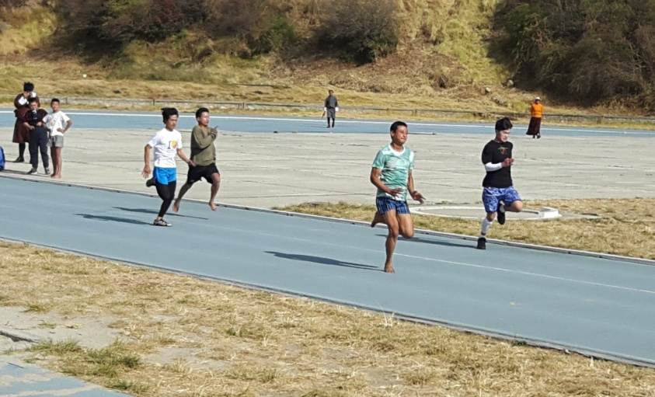

**Programs and Activities**

**Vocational and Co-curricular programs:**

The Vocational training and other co-curricular activities given below are some of the training programs offered at the centre. The vocational training is traditional based and which suits the capacities of the students. New skills depending on the requirement of the students are included annually.

**Main Vocational Courses offered:**

1. **Tailoring**

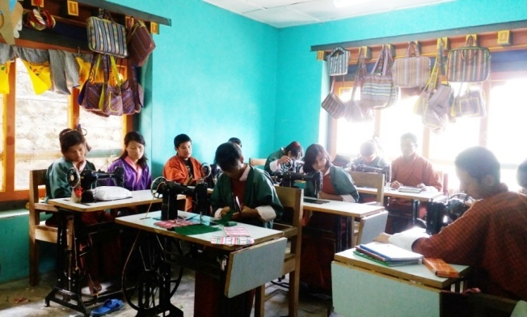 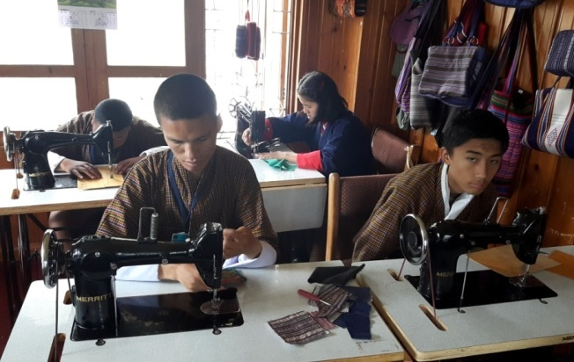

Tailoring course takes 2 to 4 years to graduate; an intellectually challenged may take more years.

1. **Traditional art and painting**

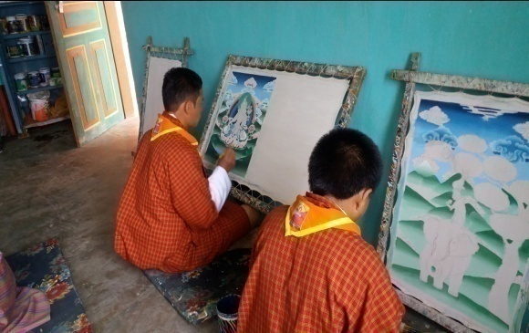 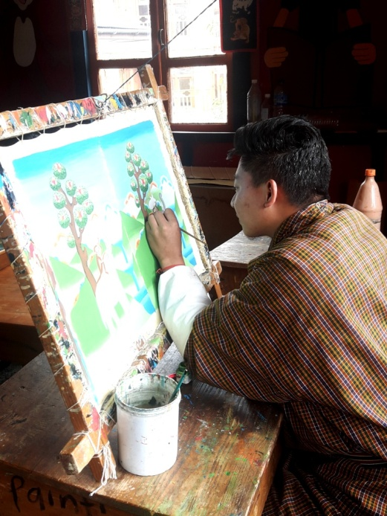

Art and painting takes 5 to 7 years to complete the course, however, it is flexible to allow the students learn at ease.

1. **Embroidery**

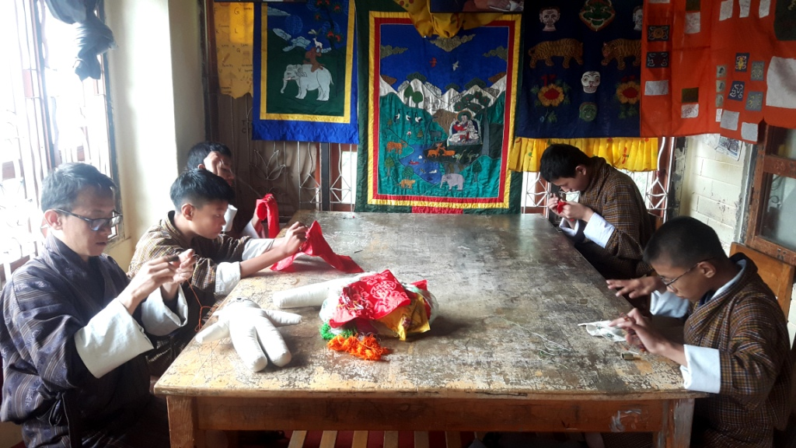

Embroidery is a high level training, it needs good hand eye coordination and good concentration. Most of the students in this class are with hearing and speaking impairment, there are few students with mild intellectual challenges. The course takes 5 to 7 years to graduate.

1. **Weaving**

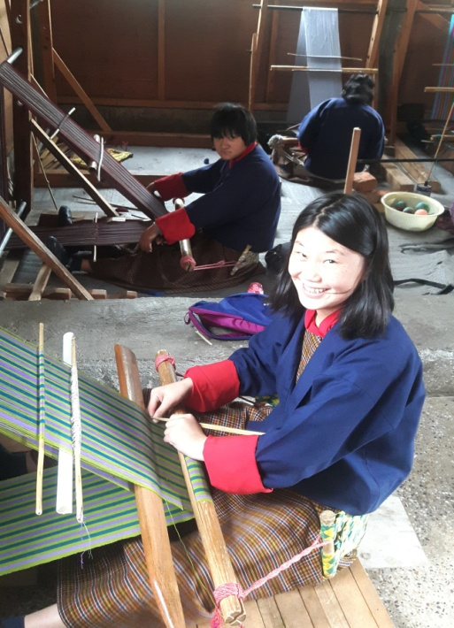 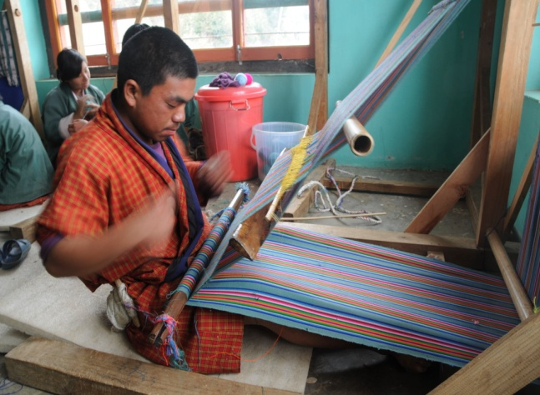

Weaving is an interesting skill development course. There are all types of youth learning weaving as it has several areas of practice. Though it is more suitable for women, men also enjoy weaving. The course takes 3 to 7 years, depending on the level of intelligence and hand coordination skills.

1. **Basket weaving(cane and plastic)**

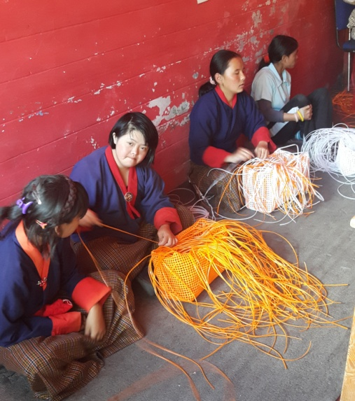 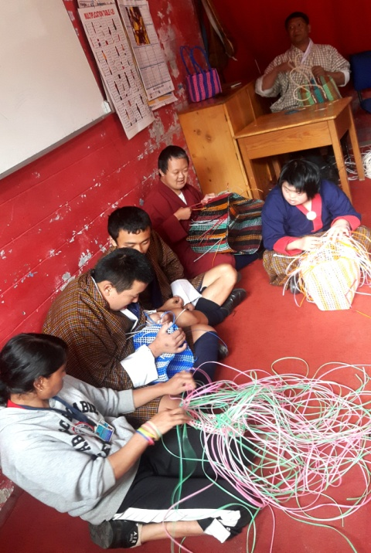

Basket weaving is pre-vocational program for Draktsho. Most of the intellectual students are placed here to determine their motor skills before transferring them to higher level training. Basket weaving develops hand eye coordination, able to sit for a long time in their seats, it also helps control behaviour problem and learn discipline.

1. **Souvenir carpentry (wood carving)**

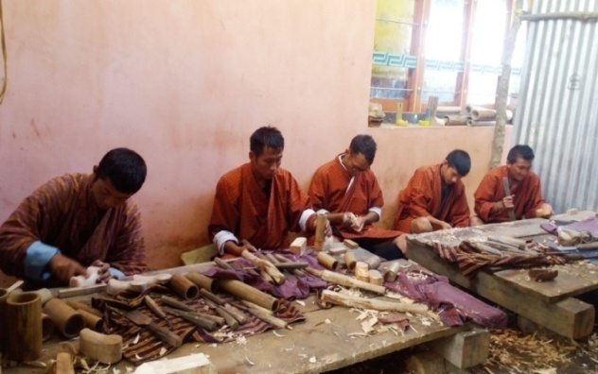 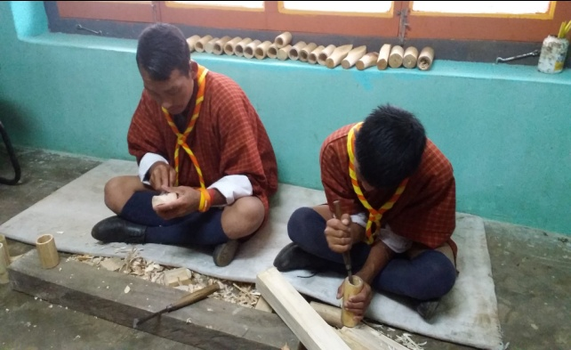

Wood carving require good hand eye coordination, besides learning carving and designing, we make small wooden souvenirs. The period of training is 5-7 years.

1. **Souvenir making(cards, bookmarks and doll making**)

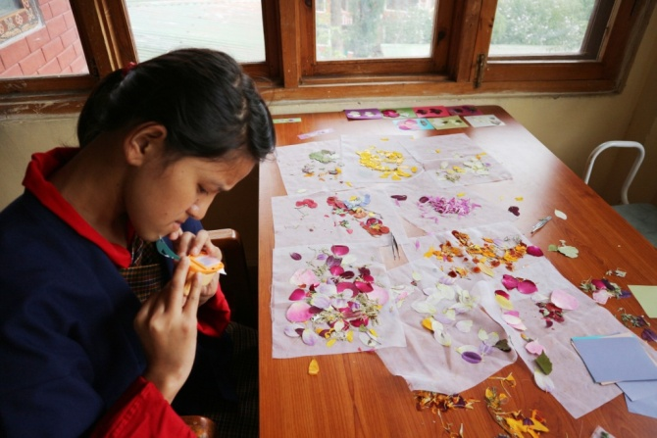

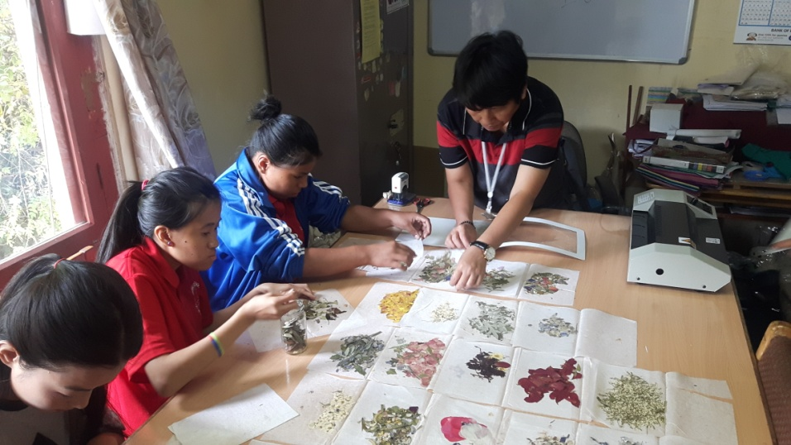

Book marks, Cards, Paper bags and boxes, small dolls are made by youth with mild cerebral palsy students. The training in this area determines the creativity of a student as they design the cards and book marks. It takes 1 to 3 years of training depending upon their individual capacity.

1. **T-Shirt and Mug Printing**

The printing training need youth with high level intelligence. We have very few students in this class.

1. **Envelope Making**

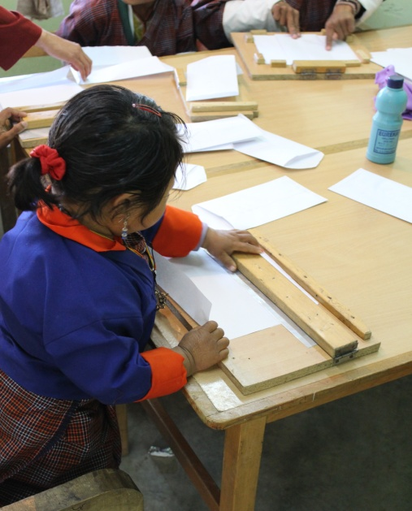 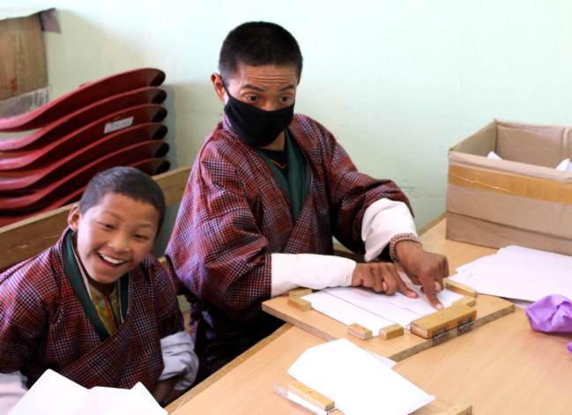

Envelopes are made by youth with moderate IQ level students and physically challenged students. It takes a group of students to complete an envelope as they lack fine motor skills.

1. **Pottery**

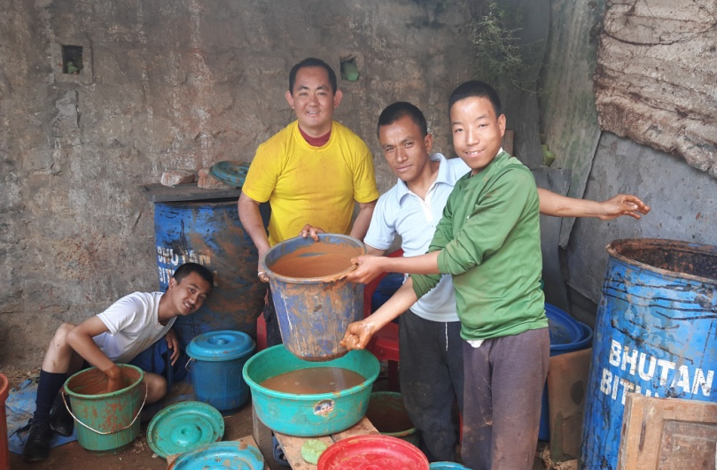 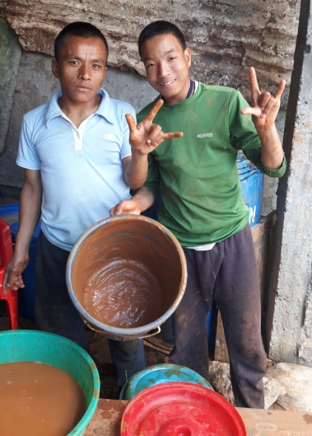

Pottery is a new skill initiated to train severely challenged students. The outcome of this training is yet to determine.

**11. Doll Making Unit**

The Doll Making Unit was initiated with support from Save the Children Bhutan with the sole purpose of engaging those students who cannot progress with other vocational trades. The doll making unit started by making traditional mini dolls and then progrsssed forward to make the "Four Friends" thuenpa puengzi. Draktsho started this new project so that these students could be happily engaged in something productive. There are 6 students in this unit who produce these soft cute teddy bears that are supplied to DUSIT D2 Hotel in Thimphu. This is the first of its kind production in Bhutan made by youth with disabilities.

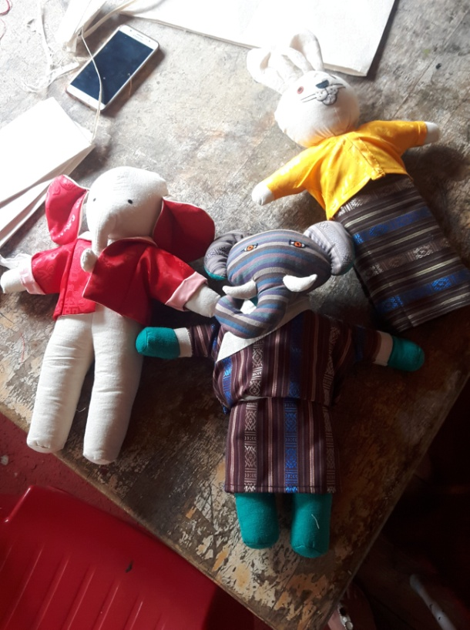 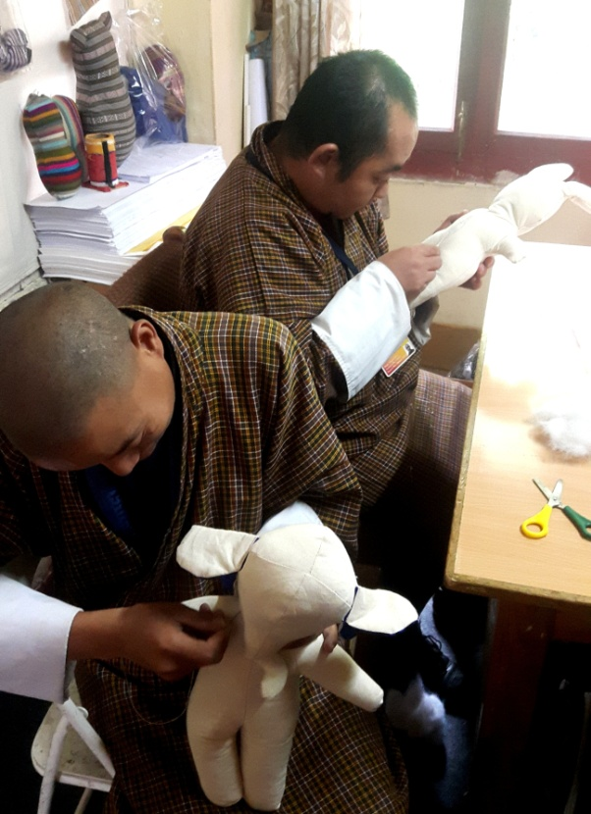

**12. Special Education:**

Special Education has always been one of the core activities of Draktsho since the beginning. The students are taught 3 subjects, English ,Maths and Dzongkha for 1and half hours every day and this is mandatory for all students. There are young children aged between 7-17 years who need Special Education and other life skills training on daily basis. Apart from basic academics the students in this unit are taught the activities of daily living(ADL) skills, social skills, singing, drawing and music to improve their behavioural and social skills.

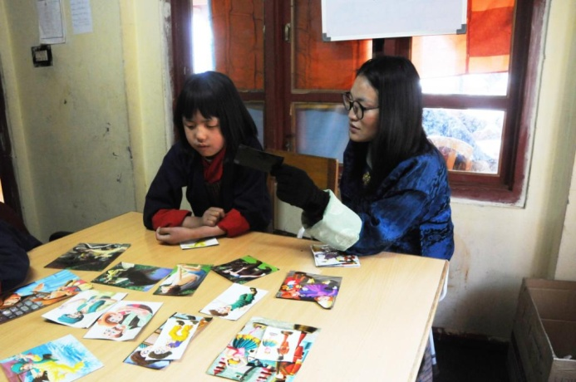 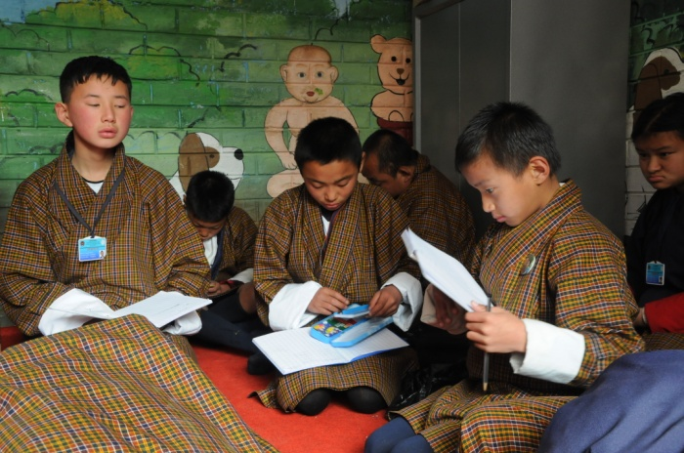

**Life skills offered:**

1. Personal management skills
2. Sign language(communication skills)
3. Social Behaviour, domestic behaviour
4. Work related or Functional Academic
5. Safety skills
6. Occupational skill and basic education(Special education)
7. Vegetable and Flower Gardening
8. Sign Language

**Co-curricular Activities:**

1. **Social skills**: dancing, singing, acting and cultural disciplinary programs are taught to the students to built their communication and socialization skills. These activities not only boost's their self esteem but also make them happy and feel inclusive.
2. **Physical fitness programs**: Draktsho is often used as the base for promoting sports for athletes with disabilities as Draktsho has maximum number of children and youth with various types of disabilities. Draktsho organizes a sports competition annually nationwide to promote the Special Olympics movement giving all special athletes a platform to showcase their abilities. This activity not only keeps one fit but brings together everyone experiencing joy, happiness, contentment and victory through inclusion.

The Special Olympics Bhutan which was founded in 2010 by people from different walks of life also operates under the umbrella of Draktsho.

In 2011, 4 athletes (2 boys and 2 girls) participated at the Special Olympics held in Athens, Greece where they participated in track and field events. The athletes won gold in the mixed relay race for the first time. Again in 2015 4 athletes with intellectual disabilities participated at the Special Olympics held in Los Angeles, California. The team brought home 6 medals (3 gold's,2 bronzes and 1 silver) in individual events. They created history in Bhutan by winning that many medals at an Olympic level. They broke barriers proving many wrong and becoming the pride of the nation.

1. Apart from the vocational training, educational and life skill program, the students are also given opportunities to development individually through counseling, personal coaching and guidance.

Following one of its long term goals Draktsho has successfully established its first branch in Rongthong ( now shifted to the new premises at Sheningkhar) Tashigang with support from the Finish government. The centre is known as Draktsho East Centre and unlike the centre based in Thimphu it provides boarding facilities to 120 students. The students at Draktsho Thimphu are day scholars and at present there are 200 students (127 boys and 73 girls) in total.

We continue to reach out to the needy and are always looking for avenues to cater our services for all.

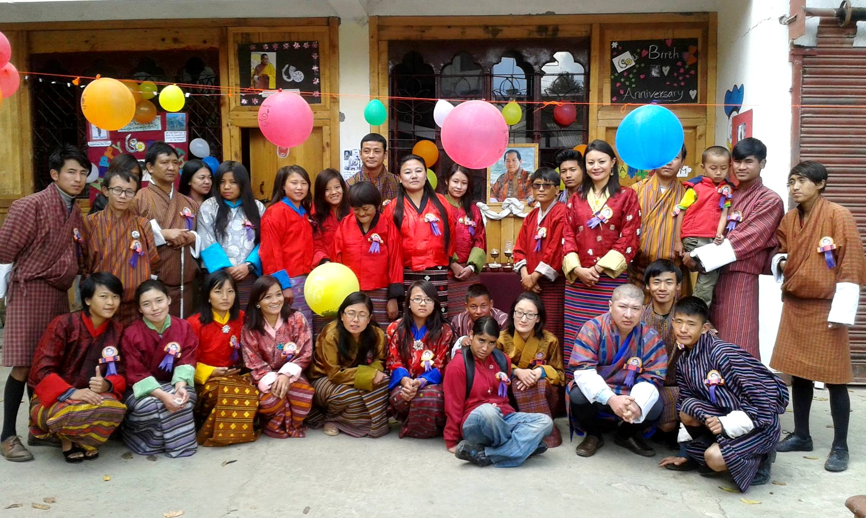

Celebrating the Birth Anniversary of Fourth Druk Gyalpo Jigme Singye Wangchuck

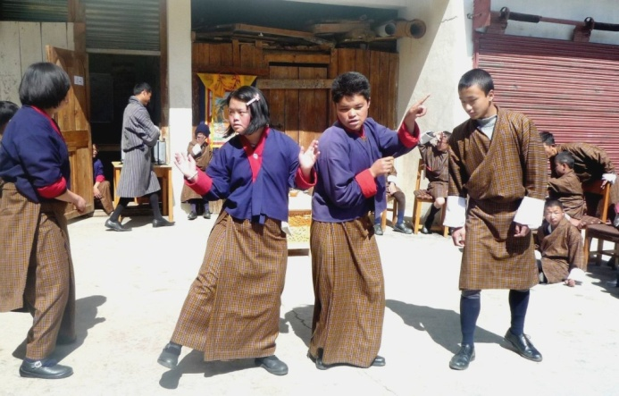 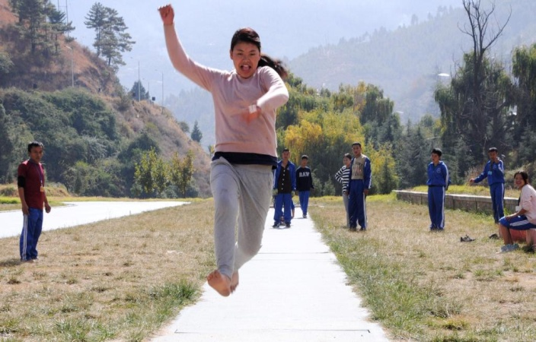

**Success Stories**

1. The construction of Academic Block was completed and this project was supported by Opening Your Heart to Bhutan.
2. Yeshi Choden and Tashi Dorji from Weaving Section and Rinzin Dorji from Tailoring graduated from Draktsho East Centre. At present all three are employed at the Production Unit in east.

**Challenges**

1. Overhead and maintenance cost has always been the biggest challenge for Draktsho.
2. No infrastructure for Draktsho Thimphu Centre. At present Draktsho is located in a rented building and wishes to build its own infrastructure.

**Our Pledged Donors**

In order to reinforce the financial constraint of Draktsho, the following organizations and individuals pledged to support the organization by being "pledged Donors" (In country donors) for Draktsho in 2015. Their contribution and concern to support Draktsho has strengthened its ongoing activities and secured its existence to continue its work well into the future to benefit the children and youth with disabilities in Bhutan. The annual contribution from the pledged donors for the year 2017 are listed below:

|  |  |  |  |
| --- | --- | --- | --- |
| **Sl** | **Name** | **Organization** | **Contribution** |
| 1 | Ashi Sonam Choden Dorji | White Tara Tours | Nu.100,000 |
| 2 | Aum Dechen Jamyang & Dasho | Singye Group of Companies | Nu.150,000 |
| 3 | Ashi Bidha |  | Nu.00,000 |
| 4 | Dasho Sonam Tobgay Dorji and Aum Tashi Pem Jamyang |  | Nu.60,000 |
| 5 | Aum Sangay Zam | Proprietor, Rinchen High School | Nu.50,000 |
| 6 | Aum Sonam Choden and Mr.Ugyen Wangchuk | Proprietor, Hotel Jumolhari | Nu.40,000 |
| 7 | Mr. & Mrs. B B Gurung | Proprietor, 8 Eleven, Thimphu | Nu.5000 |
| 9 | Mrs. Kaoru Aoki | Zhidhey Bhutan Tours and Trek | Nu.30,000 |

Thank You,

Deki Zam,

Executive Director

Draktsho

Email. [dekzang@hotmail.com](mailto:dekzang@hotmail.com)

Mob: 77273144